**Task 4 (API call)**

* Get all the countries from Asia continent / “region” using Filter method

  var countryInAsia = countrydata.filter(function(country){

    return country.region ==="Asia"

})

console.log(countryInAsia)

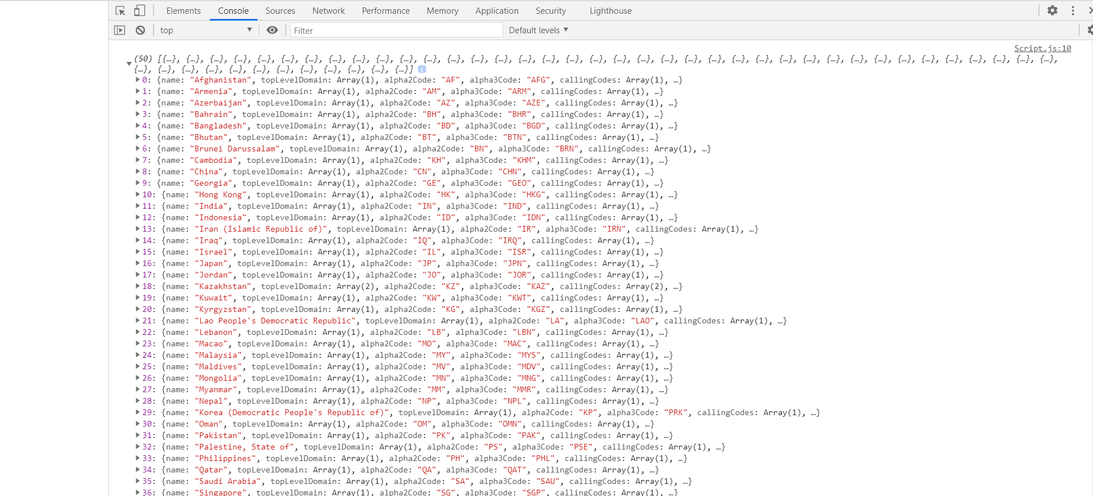

* Get all the countries with population of less than 2 lacs using Filter method
* var populationlessthan2L = countrydata.filter(function(country){
* return country.population < 200000
* })
* console.log(populationlessthan2L)

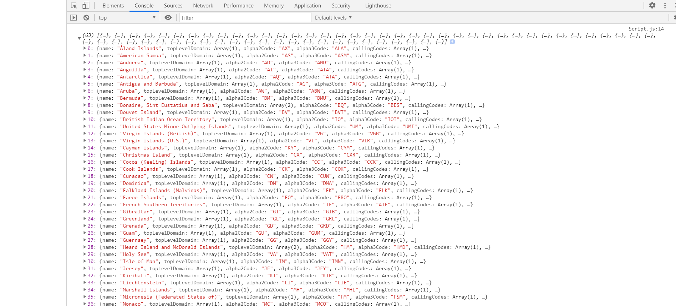

* Print the following details name, capital, flag using forEach.
* var countryDetails = [];
* countrydata.forEach((item, index) => {
* countryDetails[index]=(item.name+" "+item.capital+" "+item.flag )
* });
* console.log(countryDetails);

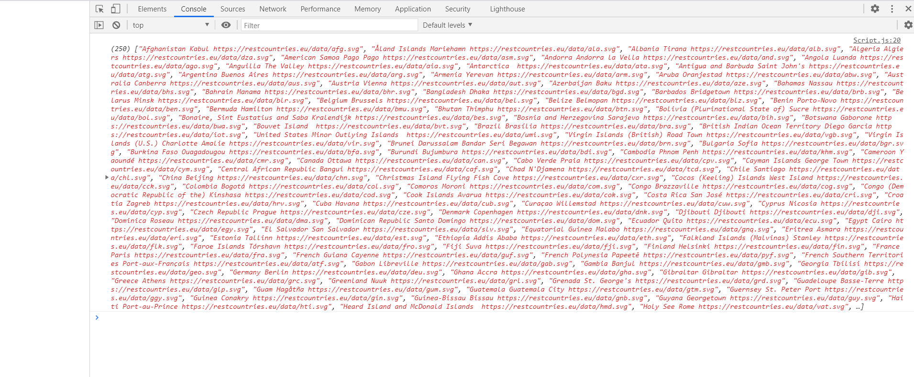

* Print the total population of countries using the reduce method.
* var countrydatapopulation = countrydata.reduce(function(result,item,index){
* return result+item.population;
* },0);
* console.log(“The Total Population is ” :countrydatapopulation)



* Print the country which uses US Dollars as currency.
* var countryuseusdollars = countrydata.filter(function(country){
* for(i=0;i < country.currencies.length;i++){
* if (country.currencies[i].code === "USD"){
* return country
* }
* }
* })
* console.log(countryuseusdollars)
* }

